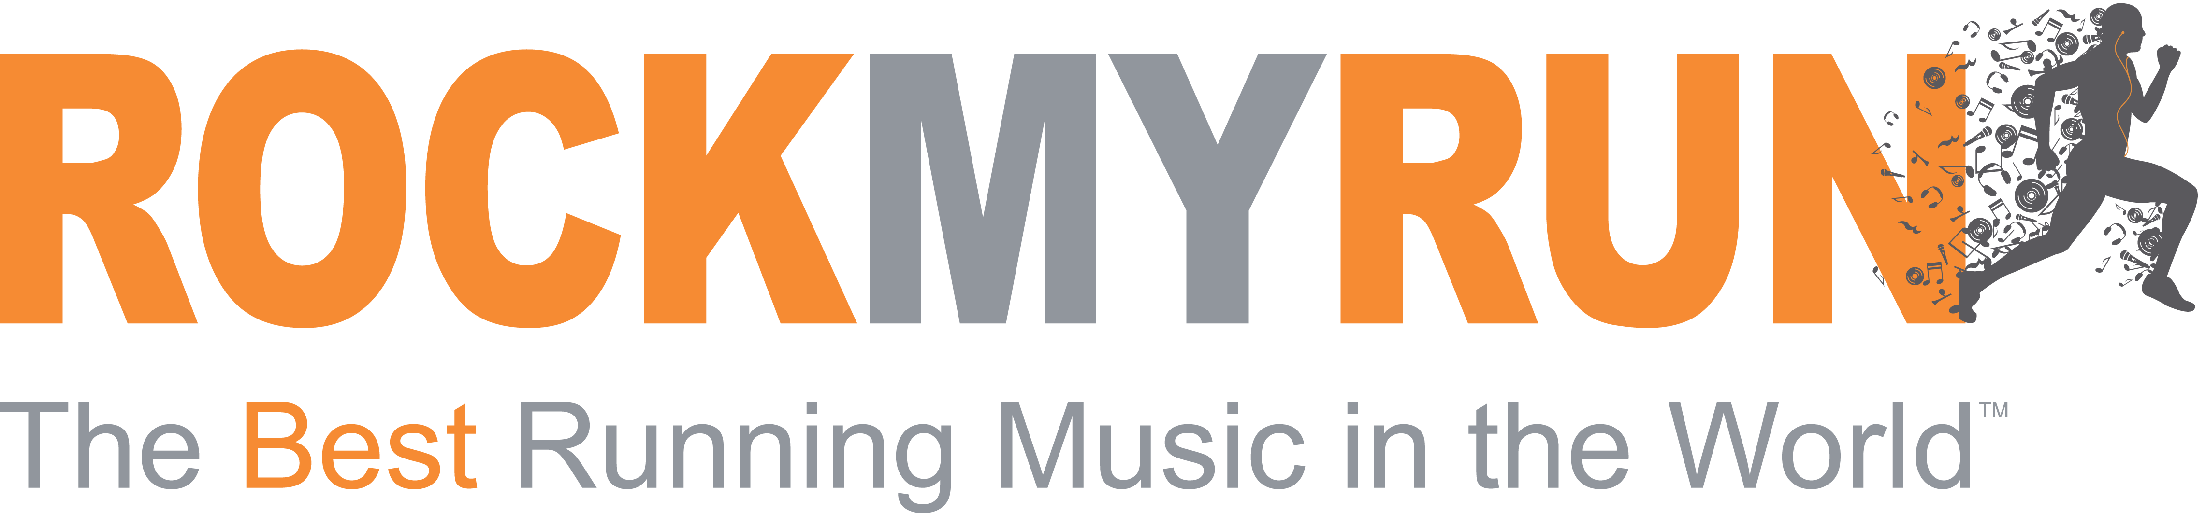

2015 Press Kit

MEDIA CONTACTS
Megan Stillerman
VP, Growth
917-623-0492
megan@rockmyrun.com

About

Rock My World was started with a mission to help people live better lives by harnessing biometric data and creating a real time, content based response to give them what they need at that moment. RockMyRun, the first product from Rock My World, is a popular, highly rated app that brings this vision to life and changes the landscape of the fitness tech market

RockMyRun’s Core Benefits:
RockMyRun moves you forward, saves you time, and helps you perform better, all while making your workout more fun. The app, available for iOS and Android devices, provides professionally created, seamless mixes that are designed specifically for exercise. The app then takes in data like steps and heart rate from smartphones and fitness tracking devices to adjust music tempo in real time to improve exercise enthusiasm and performance.

This music adjustment feature, called myBeat™ Body Driven Music utilizes proprietary algorithms to read steps per minute, heart rate and soon pace and other data coming from a user. This information is then processed and adjusted to deliver content (music tempo - BPM) in real time to match, motivate or calm someone at just the right moment. Users are also able to manually change the BPM of the mixes on RockMyRun to help them achieve a personal goal.

Scientific studies have proven that music synched to your body can have a powerful and positive effect on people running or working out. This includes increased time to exhaustion, decreased oxygen needs, increased distance covered, and more positive emotions about the workout.

Rock My World participated in a study with the one of the leading exercise research laboratories in the world, the EPARC lab at the University of California, whose results indicated that the Body Driven Music available exclusively on RockMyRun leads to statistically significant improvements with intrinsic motivation and mood during exercise.

Providing users with this type of experience will improve their exercise sessions and in turn help them in their quest to make exercise an ongoing habit. In addition, because RockMyRun takes data from smartphones and Bluetooth fitness wearables, the app positions these devices as ongoing, essential pieces to the workout experience, increasing their usage occasions and stickiness.

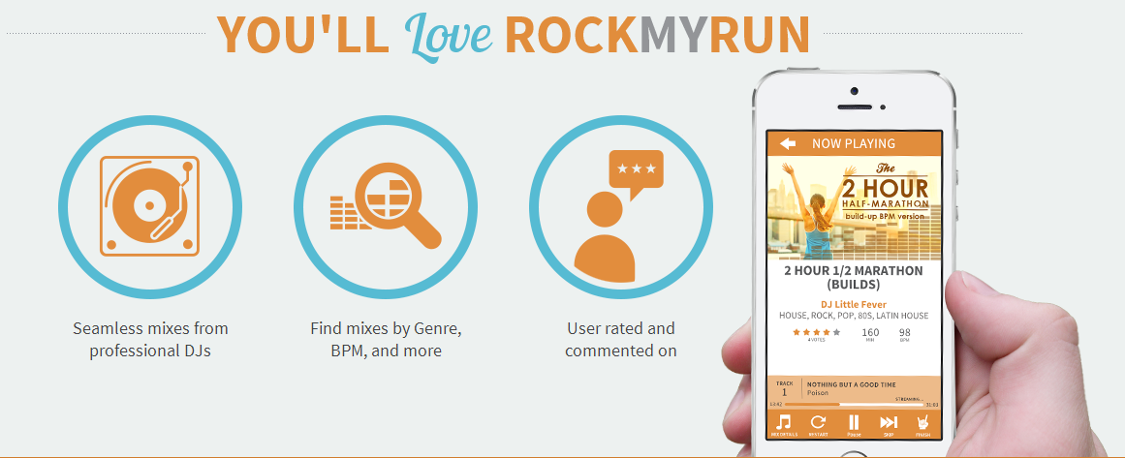

Quick Facts

Company: Rock My World
- Product: RockMyRun

Founded:
- 2013 in San Diego, CA

Co-founder and CEO:
- Adam Riggs-Zeigen

About:
Rock My World Inc. was founded with a passion for helping people get and stay fit through the fusion of music and technology – a concept referred to as Body Driven Music™. The company takes data from smartphones and fitness wearable devices and uses it to adjust music tempo in real time to help people have more fun, perform better and simply put, “get more” from their workouts

RockMyRun, the first app from Rock My World available for iOS and Android devices, combines professionally created, DJ’d mixes and playlists that have been designed to motivate people during exercise with innovative, technology that adjusts music tempo in real time based on biometric data. Body Driven Music™ is personalized for each user, allowing them to have more fun, perform better and feel up to 35 percent more intrinsic motivation during every workout.
.

- Available for download:
- iTunes
- Google Play

Website:
http://www.rockmyworldcorp.com/
www.RockMyRun.com

Social Media:
RockMyRun @RockMyRun RockMyRun

Membership Options

- RunRocker: is free and provides access to mixes that are 45 minutes or less in length in an ad supported environment. Users can listen to an unlimited number of standard mixes and cache/download mixes for offline playing through the app.
- Rockstar: provides access to the full music catalog (hundreds of mixes ranging from 30 minutes to four hours long), as well as the continuous play feature allowing users to play their mixes back to back without interruptions or commercials. The Rockstar membership is free of display and audio ads and is available in three options:
  - Annual: $35.99/year (works out to $2.99/month)
  - Quarterly: $12.99 for 3-months (available via online purchase only)
  - Monthly: $4.99 per month
Rockstar members also have unlimited access to the full suite of myBeat™ Body Driven Music modes including:
- myBeat™ MANUAL: Users manually adjust the tempo of any of the mixes and run/walk/cycle/workout in time to the music. This feature is available for iOS and Android devices.
  - myBeat™ STEPS: Using data from the iPhone accelerometer and pedometer, RockMyRun dynamically adjusts the tempo of the mix to match footstrike. This feature is specially designed for runners and walkers looking to be in sync with the music wave. This feature is currently available for iOS and Android devices.
  - myBeat™ HEART: Adjusts the tempo of the music to respond to physical exertion as measured by a user’s heart rate using heart rate data transmitted via Bluetooth from any wearable heart rate device. While this feature is great for runners and walkers, it also brings the excitement of personalized, body driven music to users participating in cycling, resistance training and non-cadence based activities. This feature is currently available for iOS and will be available soon for Android devices.

myBeat™ Technology

RockMyRun receives data from smartphones or Bluetooth wearable fitness devices to create a real time response to manipulate the music. This ability to adjust the music and BPM is called myBeat™ Body Driven Music Technology. This unique feature adjusts the tempo of the music in order to match the current exertion level or motivate the user to push a little harder.

myBeat™ is available in three modes
- myBeat™ MANUAL: Users manually adjust the tempo of any of the mixes and run/walk/cycle/workout in time to the music.
- myBeat™ STEPS: Using data from the iphone accelerometer and pedometer, RockMyRun dynamically adjusts the tempo of the mix to match footstrike. This feature is specially designed for runners and walkers looking to be in sync with the music wave.
- myBeat™ HEART: Adjusts the tempo of the music to respond to physical exertion as measured by a user’s heart rate using heart rate data transmitted via Bluetooth from any wearable heart rate device. While this feature is great for runners and walkers, it also brings the excitement of personalized, body driven music to users participating in cycling, resistance training and non-cadence based activities.

Upcoming myBeat™ features:
- myBeat™ COACH: Using the GPS data available through smartphones, RockMyRun will adjust the tempo of the music up as a user fatigues or falls off his or her pace goal during a ride, run or walk. This feature is expected to launch in early 2015.

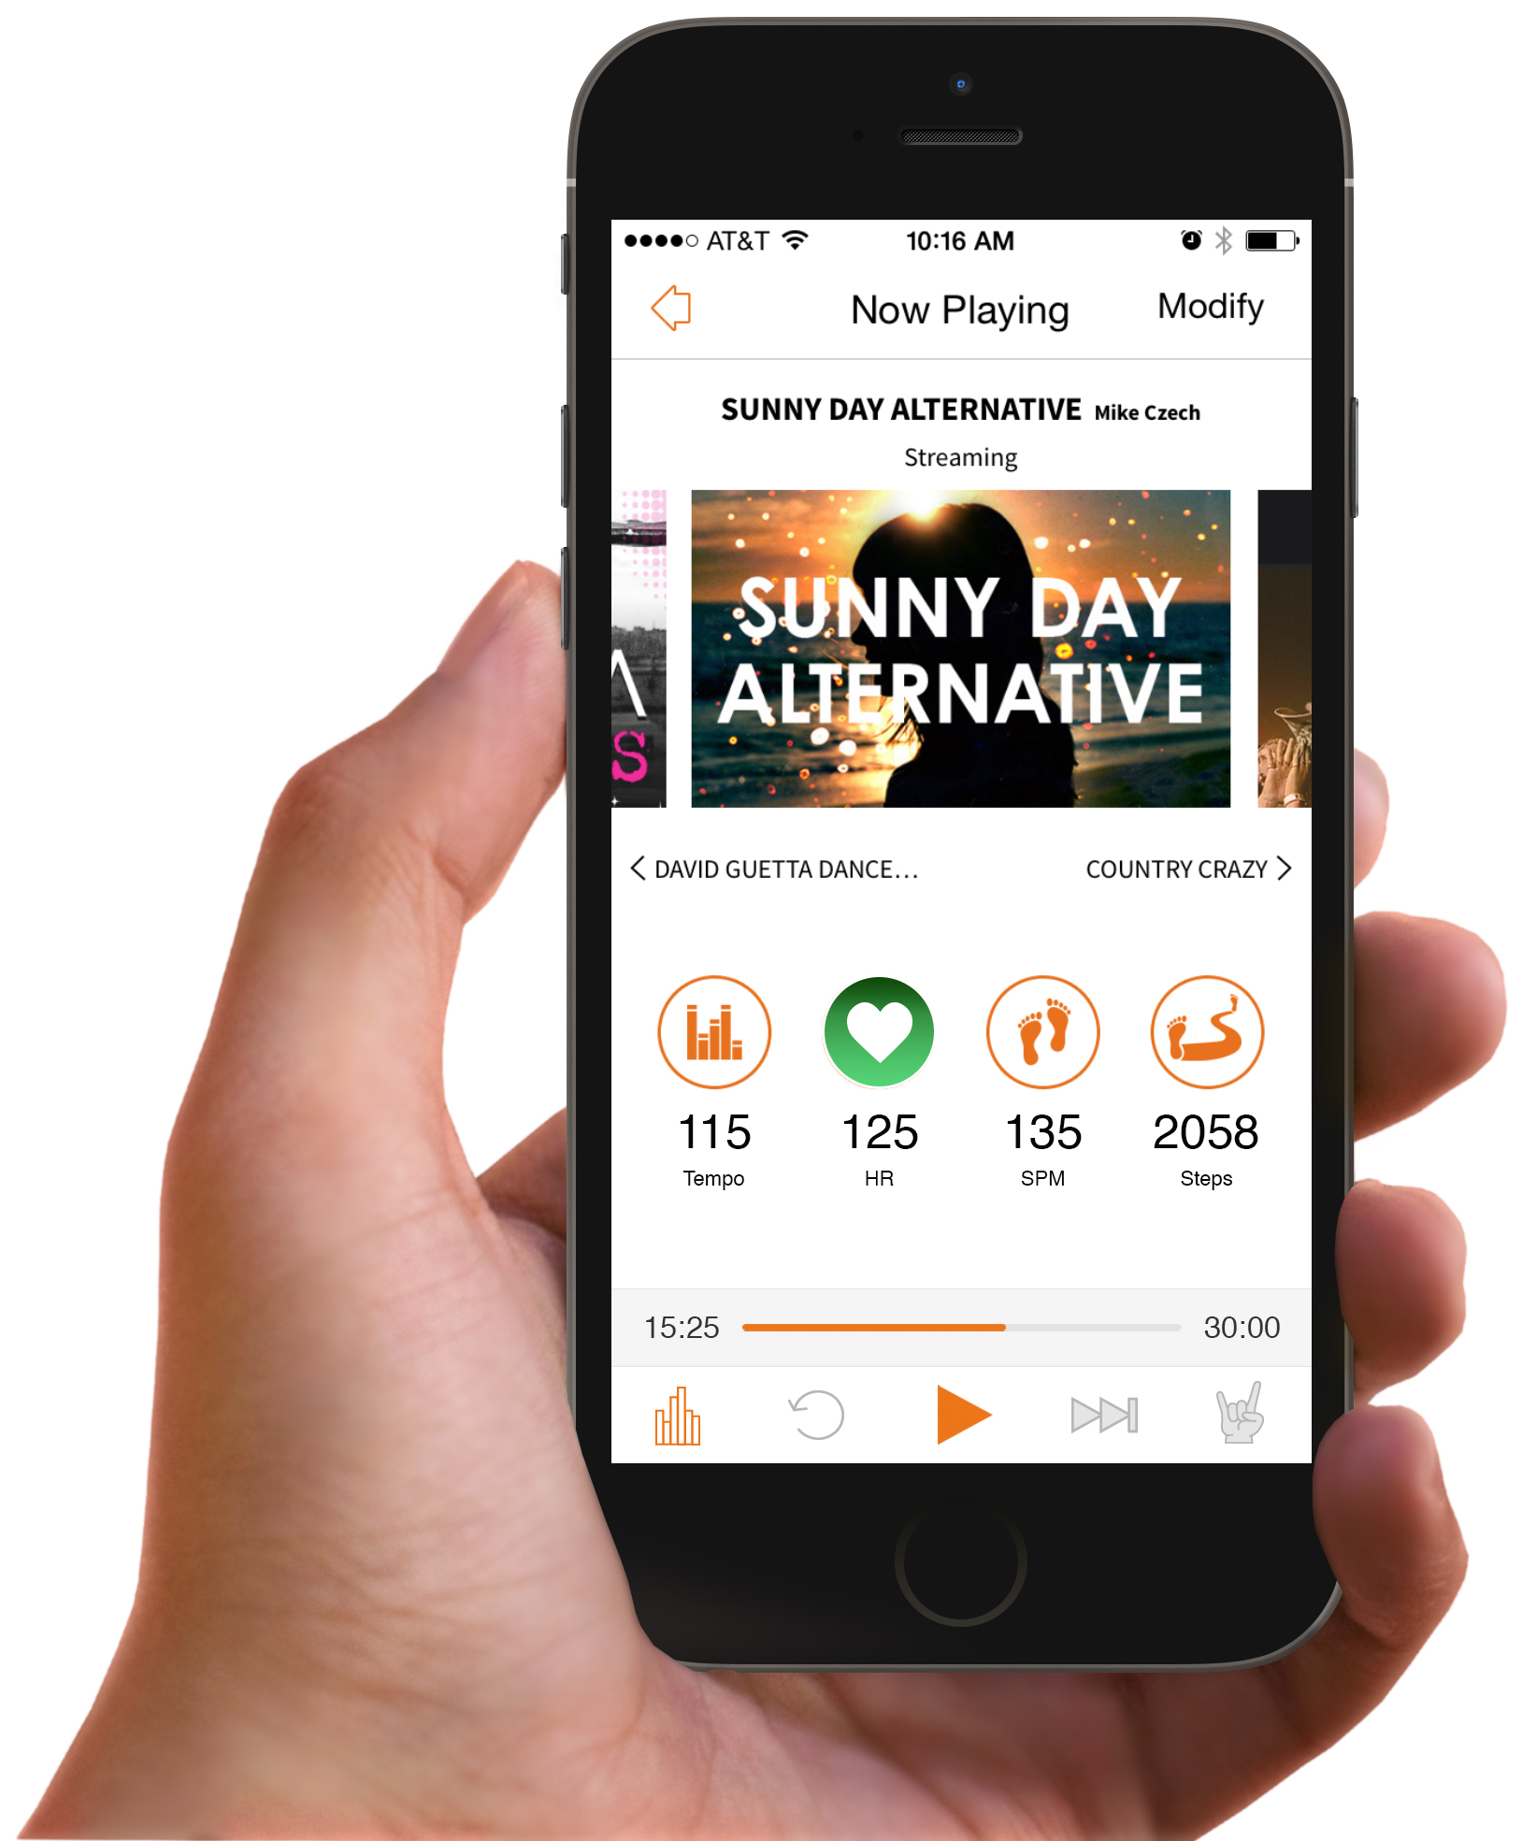
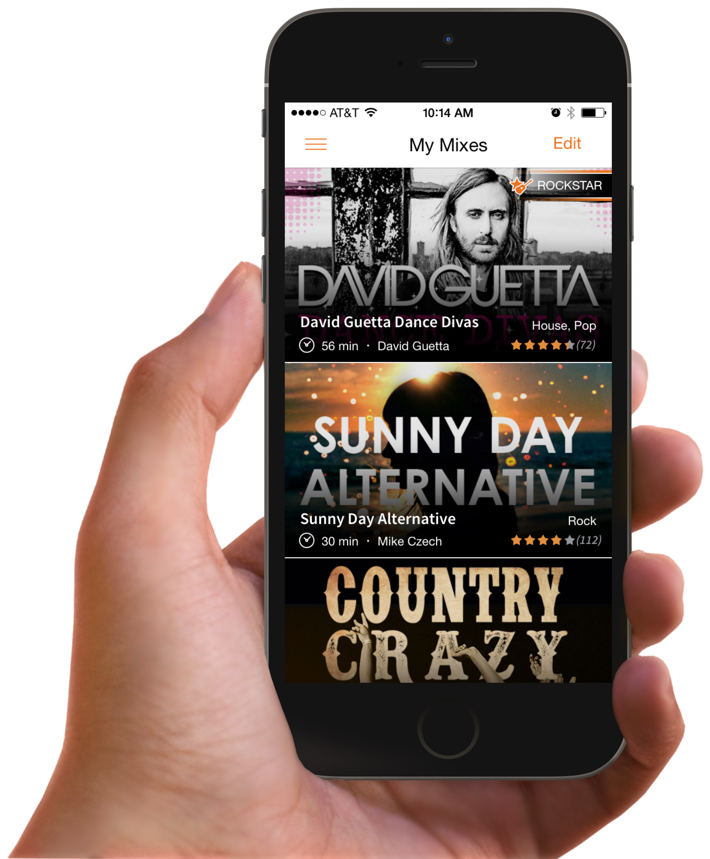

Mixes

RockMyRun features seamless, high energy mixes created by DJs (125-175+ BPM) that are searchable in several ways including, but not limited to genre, artist, activity, suggested mixes, recently released, mixes that sync to your steps and more. Genres offered on the app are house, rock, pop, hip-hop, 80’s, dubstep, country, Latin house, oldies, drum and bass, 90’s, Christian rock, bmore, classical, reggae, R&B, and season.

In order to provide the most personalized experience, RockMyRun users are able to find themed mixes for anything from 5K training to a specific BPM range. The mixes are created by DJs from around the world and are specifically designed for running and those working out.

Bios

Adam Riggs-Zeigen – Co-Founder and Chief Rocker
Adam is mobile industry veteran, software developer and former touring DJ who has combined his personal passions and expertise in product management, marketing and business development to launch and lead innovative businesses.

Adam is currently the co-founder and current Chief Rocker at Rock My World, Inc. a San Diego based fitness technology company. Rock My World is the company behind RockMyRun, a top 20 fitness app for IOS and Android that takes data from smartphones and fitness tracking devices and dynamically adjusts music tempo in real time to improve exercise motivation and outcomes. Initially launched in 2013 RockMyRun, has become the premier fitness smartphone application with over half-a-million downloads and featured in the New York Time, Boston Globe and on the Today Show.

Before founding Rock My World, Adam spent 7 years at Qualcomm, a Fortune 500 mobile technology company, in senior business development and product management roles. He worked with application developers, mobile operators, and marquis accounts including Universal Music Group, Verizon, Major League Baseball and Fox television networks to help them better monetize their content in a mobile context.

Prior to Qualcomm, Adam founded two other companies and toured as a club DJ playing both nationally and internationally. He holds a BS in Economics from UC Santa Barbara and an MBA with emphasis in Entrepreneurship from SDSU. Ultimately, it was Adam’s dedication to his own health and fitness and his desire to enable people to better experience exercise that led him to start Rock My World. By creating an disruptive product that blends high energy motivational music with step, heart rate, GPS and other readily available workout statistics, Adam and his team are changing the way that music can be used to motivate a healthy, active lifestyle. He feels incredibly fortunate to live and work his passion each day and gets his daily motivation from countless inspirational stories submitted by RockMyRun users.

Adam lives in his hometown of San Diego with his wife Ashley, is a fan of all things sports and never misses a Miami Dolphins game, no matter how awful they are.

Megan Stillerman – VP of Rockin’ Deals
Megan has spent her career building integrated marketing and launch plans for both established and emerging products. This includes the development of creative internal and external strategic partnerships and operationalizing support teams. She currently serves as vice president of Rockin’ Deals for Rock My World, Inc. a San Diego based fitness technology company where she is responsible for exposing the world to the company’s services and technology, primarily through strategic partnerships, marketing communications an infectious enthusiasm.
Rock My World is the company behind RockMyRun, a top 20 fitness app, launched in 2013 for iOS and Android that takes data from smartphones and fitness tracking devices and dynamically adjusts music tempo in real time to improve exercise motivation and outcomes.
Prior to teaming up with Rock My World, she spent seven years with ACTIVE Network, where she held progressive leadership roles focused on creating and managing of Tier 1 media and marketing partnerships, developing integrated programs and finally leading the design and launch of a new business unit focused on corporate wellness. She was born and raised in Western Massachusetts and graduated from Bucknell University with a dual major in International Studies and Spanish. After graduating she spent 8 years in New York City where launched her career in integrated marketing and promotions at Fox Family Worldwide (now ABC Family) and then went on to lead partnerships, sponsorship activation and account management activities for General Electric, A&E Network and Bravo Network at GEM Group, (now a Brand Connections company).
On a personal level, Megan has always embodied a healthy, active lifestyle. On weekends you can typically find her exploring all the beautiful landscapes San Diego has to offer with her husband and daughter. She enjoys hiking, running, yoga and anything active. She avidly volunteers with I Love a Clean San Diego and previously spent six years working with Girls on the Run of San Diego, a local non-profit dedicated to raising self-esteem with positive habits in girls eight – 12, where she served on the board from 2006-2010 and then as Board President from 2010-2012.

